
Dying Matters Awareness Week- May 2024
Event | Date | Time | Location
Our first event is a new one! End of Life Doula.  If you have never heard of this before or you would like to know more about the role of a Doula then register to join in online to find out.  This session will be led by  Dr Emma Clare  Director and Operations Executive  Chair of End of Life Doula UK    Another new event! Dogs Trust.  Learn about the work of the Dogs Trust and the scheme in place to offer comfort and reassurance to those who might worry about their dogs if they were to pass away.  The session will be led by  Sian Bourn  Supporter Relations Officer - Harefield    Continuing the theme of new events, Admiral Nurses.  Find out about Admiral nursing and the services Dementia UK have to offer.  The session will be led by  Carol Hastick  Admiral Nurse  and  Claire Ferris  Regional Development Lead - London    Our fourth new event, Maggie’s.  What is it, where is it and find out more about the variety of services provided.  This session will be led by  Louise Pottle  Cancer Support Specialist  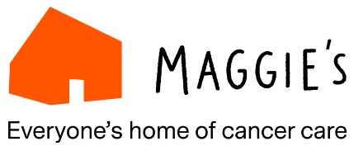 | Tuesday 7th  Wednesday 8th  Thursday 9th  Thursday 9th | 2pm – 3pm  11am -12pm  12pm – 1pm  1.30pm – 2.30pm | Via Zoom  Via Zoom  Via Zoom  Via Zoom
Please sign-up to any of these free events via email events@carers-network.org.uk and you will be sent a zoom link.
Even if you feel that these events don’t apply to you now, your attendance will enable you to share what you have learnt with others afterwards who may need this information. Looking forward to seeing you there and then!

